**Department of Electronic and Telecommunication Engineering**

**University of Moratuwa**

EN 2090 – Laboratory Practice II

**ANALOG POWER SUPPLY UNIT**

**PROJECT REPORT AND DATASHEET**

NAME INDEX NO:

D.M.A.I. DIVISEKARA 170150A

W.S.D. FERNANDO 170168K

G. GAJANAN 170170J

P.K.G. GAMAGE 170173V

Supervised By: Mr. Nipun Perera

This is submitted as a partial fulfillment for the module EN 2090:

Laboratory Practice II

Department of Electronic and Telecommunication Engineering

University of Moratuwa

7th of July 2018

**ABSTRACT**

Analog power supply is a device to convert the AC voltage to a desired DC voltage within a specific error margin by regulating and rectifying the alternative voltage. The details which are regarding the designing and implementation of Analog Power Supply is consisting in this report. The output voltage of the power supply is approximately 10V. The maximum current which can passing through the load is 10 A because of the power rating of 100W. This is designed using without any discrete elements or any ICs.

**INTRODUCTION**

**Description**

The power supply unit are normally used to give a constant DC voltage or DC current to a given load. The main parts can be allocated to different sections.

1. Step down transformer

the transformer is used to step down the AC voltage 230V (rms) to 15 V peak to peak with the current of 8A .

1. Full wave rectification circuit

As the AC wave forms are residing the power two half cycles which are opposite in polarities, it is important to rectify both the half cycles to get the maximum power into the system. AS there is a possibility of passing high current we use two bridges parallel in order to prevent high current . as well we’ve used 3 capacitors parallel in the rectified output in order to reduce the ripple effect.

1. Cooling Fan

The cooling fan is used In order to reduce the heat which is because of flowing of high current and to pump in cool air to the inside. We have used a separate rectifying circuit for the fan.

1. Power supply circuit

The output power supply circuit consist of 3 TIP 3055 transistors for the amplification of the output current. As well there is feedback circuit to stable the output .The current limiter circuit is appeared in the power supply circuit for control the current of the output. The voltage range and the maximum current rating should be monitored through their data sheets.

Not only to that we have checked the circuit in the short circuit condition for the safety of the user. When designing the Power supply unit we have to consider about the following facts

* Thermal stability
* Load consideration
* Input Voltage range
* Output Current

The main objectives of the project are to

* Identify the most efficient cost effective way ( accuracy also should be considered)
* Implementation of rectifying circuit to get a very smooth output for the power supply circuit
* make a of enclosure design which is capable of cooling the unit as much as possible when it is functioning
* check the failures and develop methods to troubleshoot.

**Specifications**

* design circuits using without discrete electronic components
* the copper paths of the PCB and the and the components should be thermally stable as there may be high current passing through them
* should give an output voltage of 10V
* should be able to regulate the 15V peak to peak voltage to 10V output voltage
* the maximum power rating of the PSU is 100W . so the circuit should be capable of flowing 10A current

**The methodology**

Required components, software and equipment.

Rectifying Circuit

1. 10A10 diodes 10
2. 1N4004 diodes 4
3. Connectors 3
4. 4700uF capacitors 4
5. 330ohms resistor 1

Power Supply Circuit

1. TIP3055 transistors 3
2. 2N3904 transistors 2
3. 5.1V zener diode 1
4. 0.5Ohm 20W power resistor
5. 100ohms 7W power resistor
6. 1K resistor 3
7. 5K variable potentiometer
8. 1mF capacitor 1
9. 4700uF capacitors 1
10. Connectors 2

Other components

1. 12V fan
2. Female banana plugs 4
3. Twisted house hold electric wires
4. Circuit wires
5. Indicting LED
6. 3mm Nuts and Bolts
7. PCBs Imported from china
8. Multibond Glue
9. Plywood

Equipment

1. Drill machine
2. Plier
3. Screw driver
4. Solder Iron
5. Solder wires
6. Multi meter
7. Breadboards
8. Jumper wires

Software

1. NI Multisim 14.1
2. Solidworks 2014
3. Altium 17.1

Approach

Designing and preparing a regulating and rectifying circuits are somewhat familiar to us but dealing with high currents such as 10A was, new experience for us since we had to face many problems. Finding the components which are resist to 10A current was somewhat hard to us. Even many of those components were not available in the Sri Lankan market. Under that situation we have to buy them using online websites, such as ARROW.com One of the biggest problem was heat sinking for components such as power resistors and TIP3055 transistors. As well we try to have new experience avoiding traditional methods of circuit making. For the previous projects we did contained circuits which are made by ourselves using etching method and screen printing methods. But this time we used JLC PCB from China. It was very easy and very cheap comparing with previous methods. And also we could use two layer PCBs. Howsoever we manage to have the output well, which is 10V and the maximum current was achieved well.

Block diagram showing the functionality

Preliminary Design

Output 100W 10A max

Current Amplifier

Full Wave Rectifier

Voltage Regulator

Step Down Transformer

AC in`(230v)

SECONDARY DESIGN (With Feedback Circuit )

Current Amplifier

Output 100W 10A max

Unregulated Input

Feedback signal

Reference voltage

Comparator circuit

Sampling circuit

Steps of the project

1.Design Considerations prior to designing the circuit

How can we handle high current in the circuit?

After the simulation of the circuit we measure the currents through each component. Then we could recognize the components that should be heat resisting. Rectifying bridge diodes should be 10A current resisting then we used 10A10 diodes for rectifying bridge. Also some of the resistors were to be high wattage.

How to find out components which are not available in the local market?

However we searched in the local market that components which are rarely available in the local market. Then the components that we can’t find out from the local market we could find them in international web sites such as aliexpress and arrow.com then we manage to order them carefully.

How to protect from the higher currents?

We could observe the higher current situation using multisim simulations. Then we can avoid them using a current limiter without using traditional methods such as fuses. Calculation for the current limiter was done in order to limit the maximum current as 10A.

**Designing the PCB**

* we have made a hand drawn sketch with the consideration of the current limits and the output voltage with the regarding components
* then we design the circuit using “Multisim software ” and simulate the circuit . Then we’ve identified the developments that should be done in the Circuit in order to get the expected output
* then the final circuit design was finalized and discussed about the final design with the supervisor about the feasibility and the rated components that should be used for the final circuit
* the final schematic for the circuit was designed using the Altium 16.0.5 software.
* After designing the schematic we designed the Printed Board Circuit (PCB) Layout using Altium 16.0.5 software

**Making the PCB**

In this time we’ve drive away from the traditional method . so we imported PCB by JLC PCB in China because it’s cost effective than the local market and we can get the double layer PCBs instead of doing screen printing then etching with FeCl3 .

**Testing and getting the reading from the PSU created**

* We tested the circuit for different loads and different input voltages to verify the functionality and the range of the usage for the PSU . so that we have determined that the minimum load which gives 10V correct output is 10 Ohms .
* The other data sheet requirements are done by checking the data sheets and the other resources.

**Enclosure**

The maximum power dissipation of 100W. Hence the circuit get heated up at the higher currents even though the heat sinks were used to dissipate the heat from the power transistors and the regulator.so we decided that it would be prominent if we apply a DC fan to suck the heat out from the unit and dissipate it to the surrounding. Hence we built a simple enclosure to accommodate both the circuit and the fan. The preliminary design was done using the hand drawn sketches and then we used Solid works for the design purpose.

**Bibliography**

1. Specifications and required outcomes were given by our supervisor Mr. Nipun Perera.
2. <https://www.snapeda.com/>
3. <https://www.arrow.com/en/products/tk20pr050je/ohmite>
4. <https://www.electronics-tutorials.ws/blog/variable-voltage-power-supply.html>

**Data Sheet – Power Supply**

**Appearance**

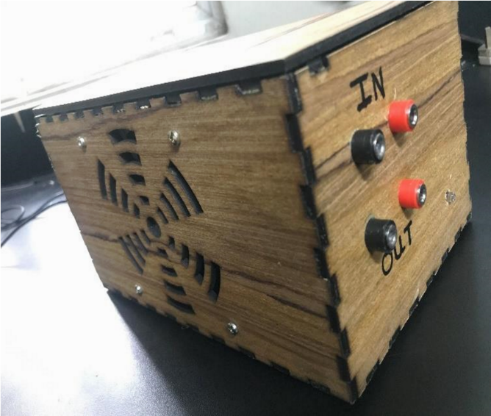

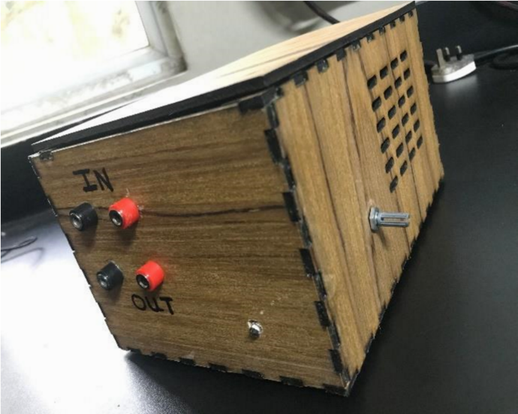

**Description**

This is a DC power supply designed in ordered to give 10V up to 10A current. That mean gives power up to 100W. input for this device was given by 15 V p-p transistor. This device consists of four main parts such as Rectifying circuit, Current amplifier, Feedback circuit, current limiting circuit. Current limiter limits the current less than 15 A. There is a fan to eliminate the heated air inside the circuit.

**Schematics**

Main regulator circuit

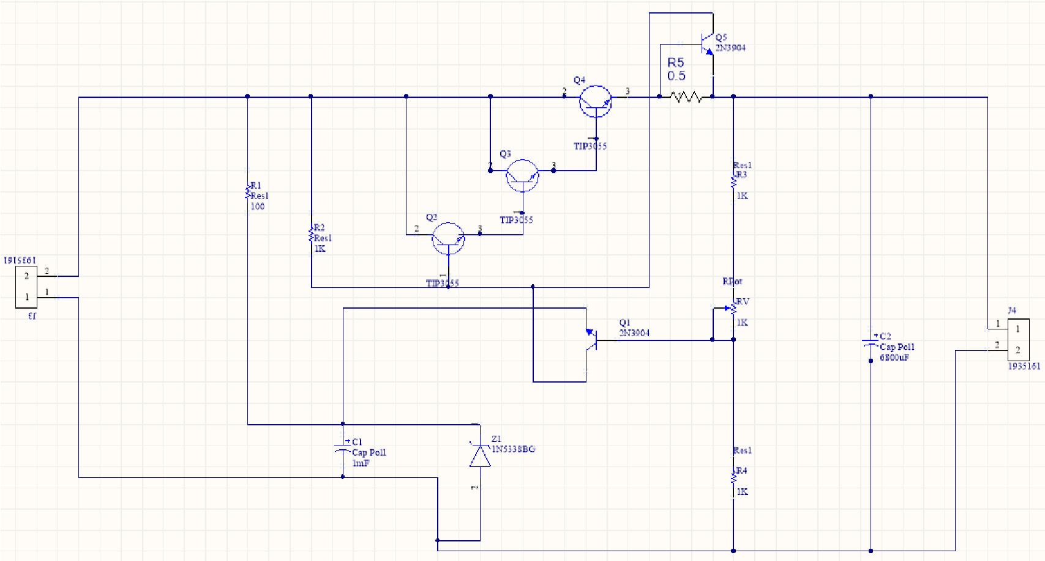

Rectifier circuit

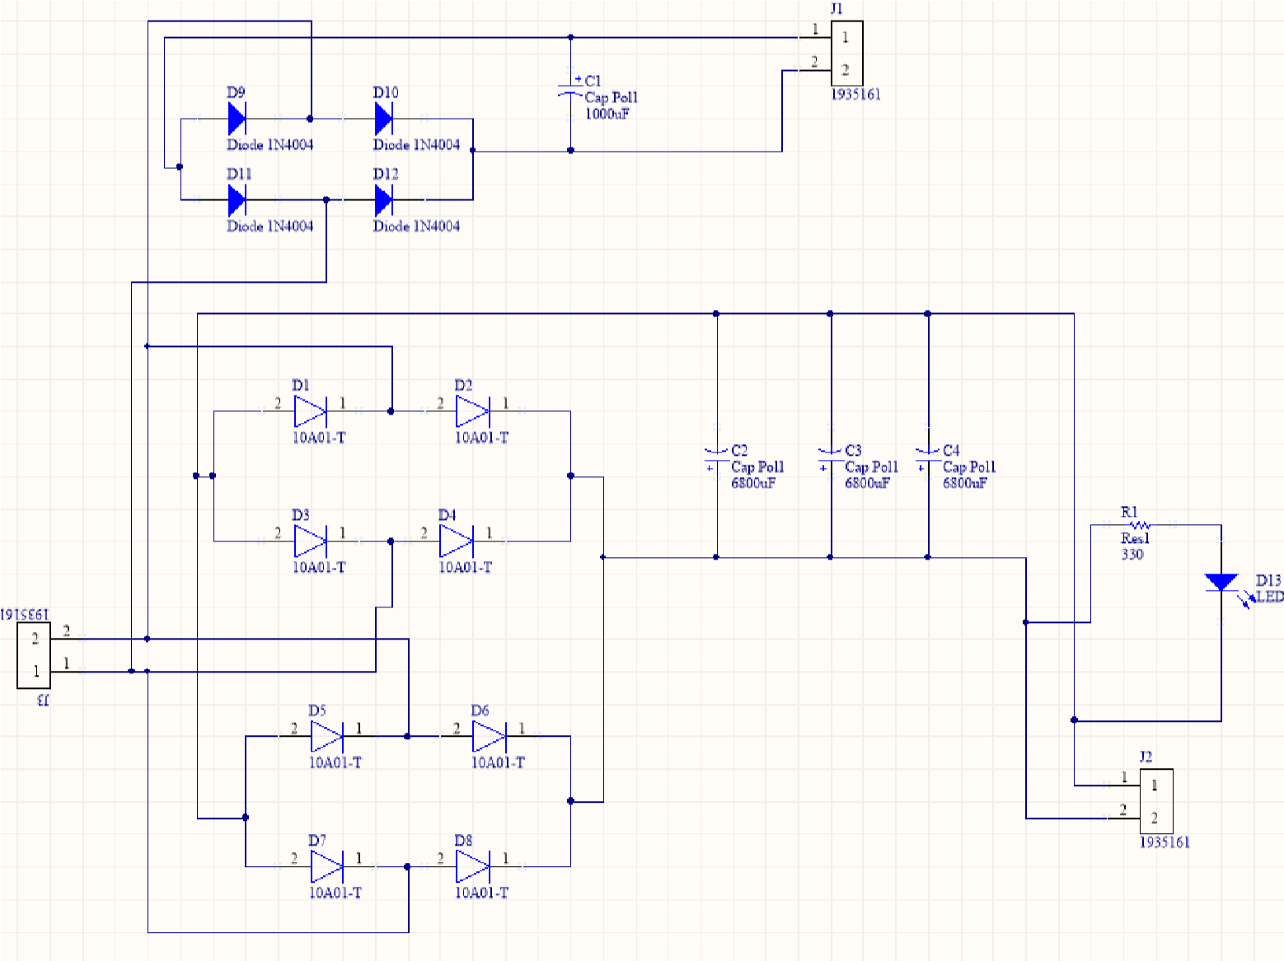

# Experimental output voltages

|  |  |  |
| --- | --- | --- |
| Resistor value (ohms) | Maximum output(V) | Minimum output(V) |
| 1000 | 12.6 | 7 |
| 100 | 12.3 | 6.8 |
| 25 | 11.9 | 6.8 |
| 12 | 10.5 | 6.8 |
| 10 | 10.2 | 6.7 |
| 5 | 9 | 6.7 |
| 4 | 8.6 | 6.6 |
| 2 | 7.2 | 6.6 |

# Characteristic Parameters

|  |  |  |  |  |  |
| --- | --- | --- | --- | --- | --- |
| Parameter | Test condition | min | typical | max | Unit |
| Input voltage |  | 11.4 | | | Vrms |
| Output voltage | Resistances 5- 10Ω | 6.7 | 1 | 12.6 | V |
| Output resistance | In order to get 10 V output | 10 |  | 1000+ | Ω |
| Drop out voltage | At the resistance 2 Ω | 3 | | | V |
| Short cicuit output current | It was not obtai ned because the maximum current of the transformer provided is 8A | | | | |
| Peak output current |  |  |  | 3.6 | A |
| Efficiency |  | 9.14% | ~50% | 65% |  |

# Output Voltage vs load resistance

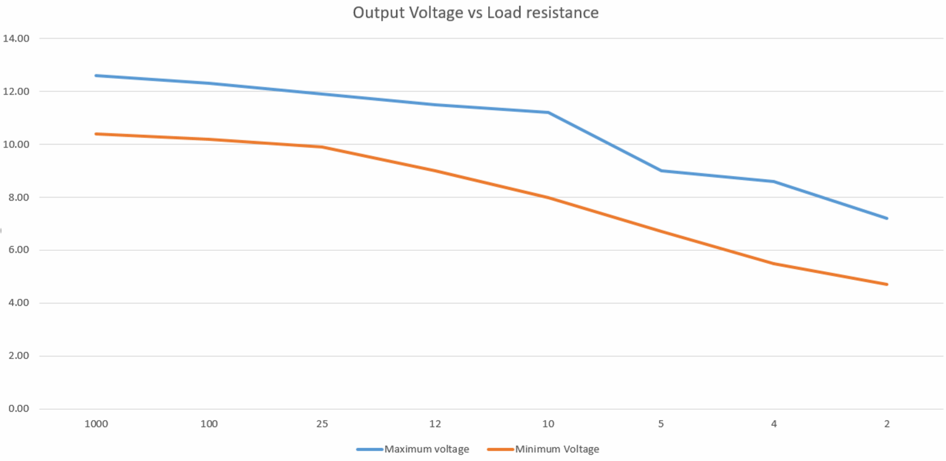

# Efficiency vs Load graph

